Getting Started with Manure Management Planner

Author: Phil Hess
Revised: 06-Oct-2010
Copyright © 2002-2010 Purdue Research Foundation.
www.agry.purdue.edu/software

1. Introduction
This guide describes how to use Manure Management Planner (MMP) to develop a nutrient management plan.
1.1. Contents
This guide covers the following topics:
- Section 2. Before you start Page 3
- Section 3. Using MMP to enter production data Page 7
- Section 4. Risk assessment Page 11
- Section 5. Allocating manure with MMP Page 16
- Section 6. Developing a manure allocation strategy Page 20
- Section 7. Using MMP to generate reports and documents Page 24
- Section 8. Solving common planning problems Page 27
This guide also includes appendices that cover file- and data-oriented tasks:
- Appendix A. Organizing your computer files Page 34
- Appendix B. How to import soil test data into MMP Page 37
1.2. CNMP Development Process
One way to think of nutrient management planning is in terms of a "process" that you go through for each plan you develop. Here are the steps in a typical process for developing and implementing a Comprehensive Nutrient Management Plan (CNMP):
1. Lay out the farm with GIS software, including field boundaries, conservation practice boundaries, and manure application setback areas, then export this data to MMP.
2. Develop the nutrient management plan with MMP by entering all production data, RUSLE2 data and risk assessment data, then planning all manure and fertilizer applications and manure transfers.
3. Develop the CNMP conservation plan with any production area or land treatment conservation practices that are already in place or are planned for the farm.
4. Generate the CNMP document and the producer activity document with MMP, then edit the generated documents to insert maps and additional required text.
5. Submit, review, deliver and archive the CNMP document and its related files.
6. Implement the nutrient management plan and keep records.
Note that this guide covers only steps 2 and 4. For help with the other steps, please consult the documentation included with the software that you will use to complete them.
1.3. Other sources of information about MMP
This guide gives a general overview and introduction to many aspects of MMP. For more specific instructions on particular areas, refer to the following documents included with MMP:
- MmpGettingStarted.doc – this guide. This document is in MMP's install folder and is also accessible from MMP's About box. It's also available from MMP's Web site: http://www.agry.purdue.edu/mmp.
- BlankForm.doc – this is a blank form that can be used to record most of the data that is required for MMP. See also document SampleForm.doc for an example of this form that's filled in. Both of these documents are in MMP's Samples folder and are also accessible from MMP's About box.
- xx_PI.doc – instructions on what information needs to be collected and entered in MMP for a state's phosphorus risk tool. These documents are in MMP's Custom folder and are also accessible from within MMP. These documents usually include links to state-specific phosphorus risk assessment documents on the Web.
- Nat_Plan_Instructions.doc – instructions for generating and completing a CNMP and other plan documents. This document is in MMP's Custom folder and is also accessible from within MMP.
- MMP's help – help for specific areas of MMP. Whenever you see a Help button in MMP, you can click it to get help for the current window or dialog box. MMP's help also includes important state-specific notes.
2. Before You Start
Be sure to review this section before you begin using MMP.
2.1. Nutrient management planning: What it is
Nutrient management planning can challenge even experienced planners. Not only are there numerous differences between types of animal operations, storage facilities, field limitations, crop needs and equipment capabilities, but there are often differences between what various states and conservation partners want to see out of the planning process.
For the purpose of this guide, nutrient management planning is demonstrating that an animal feeding operation has sufficient crop acreage, seasonal land availability, manure storage capacity, and application equipment to manage the manure produced in an environmentally responsible manner. Theoretically you could do this with a calculator and a piece of paper; in all likelihood, you will probably want to use software like MMP to assist you.
Nutrient management planning can also be done for farms that import and utilize manure, but don't generate any manure. Likewise, plans can be developed for farms that don't have anything to do with manure, using commercial fertilizer to meet all of their crop nutrient needs. MMP can be used with these types of operations as well. However, since both types engage in activities common to an animal operation as far as nutrient management is concerned, they won't be addressed specifically in this guide.
Nutrient management planning is usually long-term and therefore can be described as strategic planning to emphasize its long-term nature. You can also think of a plan as a feasibility study of an operation's ability to manage the manure it produces over the period of the plan.
2.2. Nutrient management planning: What it isn't
Nutrient management planning in the context of this guide is not the same as recordkeeping, even though accurate records are vital to revising and updating future plans. MMP includes an optional recordkeeping tool that can be used to record daily manure applications once an operation's long-term plan is complete. However, actual records of manure applications are not entered into MMP. MMP is a forward-looking planning program; recordkeeping programs are backward-looking documentation tools. Decisions about manure management made in MMP can and frequently will change as future conditions warrant; once manure is applied to a field, there's little you can do about it except record what was done.
Nutrient management planning in the context of this guide is not really about short-term decisions either, such as what to do next week or next month, even though these tactical planning decisions are critically important to managing manure properly and meeting the goals of the long-term plan.
2.3. Collecting good data
Collecting enough data to create a good plan usually requires spending many hours with the producer and possibly several site visits to the operation. At first this may seem daunting. After you've done a plan or two, you will become more efficient and the data collection process should go faster.
MMP includes a blank form that can be used to record most of the data that is required. Another option is to enter data directly into MMP during the data collection process.
Some data is more critical than other data. Section 8 discusses some of the pitfalls to avoid with three of the most critical types of data: soil test results, manure analyses, and annual manure production estimates.
You'll find that GIS software is helpful in generating accurate field size and soil type data.
2.4. Typical use of the software
Here is a typical sequence for developing a nutrient management plan:
1. Use your GIS software to lay out field and application setback boundaries and determine field sizes and soil types.
2. Export data from your GIS software to MMP so you don't have to re-enter this data in MMP.
3. Enter the operation's production data in MMP. This includes field, soil test, crop, storage, animal and equipment data provided by the producer. Field and soil test data can also be imported – see Appendix B in this guide for help with importing data into MMP.
4. Enter RUSLE2 soil loss data in MMP and run any state-specific phosphorus index or other risk assessment tool. This provides a baseline estimate of phosphorus risk without any manure or inorganic phosphorus applications.
Tip: Before you can enter any RUSLE2 data in MMP you will need a RUSLE2 database (.gdb extension) for your area. The recommended way of obtaining the right RUSLE2 database is to use this Web application. See Section 4 for more information about RUSLE2.
http://nmplanner.missouri.edu/software/national_data.asp
5. Based on the results of the risk assessment tools and other guidelines you develop, use MMP to plan all manure applications, manure transfers, and commercial fertilizer applications for the length of the plan.
6. Review the plan by running MMP's built-in and custom reports. In some cases, you may need to run the state-specific risk assessment tools again to evaluate your application decisions. The results of this step may require you to revisit the planning decisions made in step 5.
7. Generate state-specific reports tailored to meet a range of production and compliance needs. These may be MMP custom reports, CNMP and similar documents, or other reports that you compose yourself with a word processor.
2.5. Mastering your computer
To successfully create a nutrient management plan with MMP, you will not only need to become proficient in using the program, but also in using utility programs such as Windows Explorer to copy, delete, rename and backup files. Appendix A includes useful tips on organizing your files.
This guide assumes you have a basic understanding of Microsoft Windows. For help with understanding Windows concepts and conventions, refer to the Windows help or one of the many books or Web sites on Windows.
2.6. Terminology and assumptions
Make sure that you understand what MMP means by the various terms discussed below before using it.
2.6.1. Field
For the purposes of nutrient management planning, a field can be defined as the largest unit of land that has the following characteristics:
- Same crop rotation, yield goals, and tillage.
- Can be represented by a single soil test sample. Extension fertilizer recommendation guidelines often limit this to 20-25 acres per soil sample, but this may differ from state to state.
- If the field will receive manure, the spreadable (non-setback) part of the field can be completely and uniformly manured in the same month, with the entire spreadable area receiving similar amounts of available manure nutrients.
Your state may also have guidelines regarding the definition of a field for conservation or nutrient management planning.
In general, all parts of a field are managed the same in the context of nutrient management planning. However, sometimes you may need to subdivide fields into smaller units than what you might come up with based on the above criteria. Here are some examples of cases where additional subdividing makes sense:
- If differences in soil type within a field result in different fertilizer recommendations, then it probably makes sense to subdivide the field by dominant soil type into manageable subfields. GIS software makes this easy since the soil type boundaries from the county's digitized soil survey can be displayed on the farm map when you're drawing field boundaries.
- If a risk assessment tool produces different results for significant acres depending on the part of the field that's assessed, then it probably makes sense to subdivide the field. This could result from differences in slope, distance to water body, or other field or soil characteristics used by the risk assessment tool.
- Areas of a field in filter strips and other conservation buffers that are planted to a different crop than the rest of the field should always be treated as separate subfields.
- Although technically the part of a field within a manure application setback is managed differently (cannot receive manure) from the spreadable part of the field (can receive manure), MMP and GIS software allow these areas to be treated together as the same field due to the irregular field boundaries that often result if subdivided. However, you can subdivide these fields into spreadable and non-spreadable subfields if you want. Again, GIS software makes this easy since it displays the outline of the setback areas on the farm map when you're drawing field boundaries.
2.6.2. Field identification system
You can use whatever system you want to identify fields in MMP. For each field, you enter a main field ID and an optional subfield ID. The subfield ID is useful if you've subdivided a field in order to manage the subfields differently. The only requirement is that the combined field ID and subfield ID must be unique within the plan. Note that you don't have to use subfields, although they can be extremely useful if you need to subdivide fields as discussed previously. You can also enter an optional farm ID for each field, although this is not used in field identification within MMP.
Here are two common ways of identifying fields in MMP:
- Farmer's field naming system, with subfields if you need to subdivide the fields. You can also enter each field's FSA farm, tract and field number in the columns provided for use as a secondary field ID.
- FSA tract and field. For example, you can combine a field's FSA tract and field numbers and enter this as the main field ID and reserve the subfield ID for when you need to subdivide FSA fields. Or you could enter the FSA tract number as the main field ID and combine the FSA field number and any subfield number for use as the subfield ID.
Note: MMP uses the terms field ID and subfield ID, whereas GIS software may use the terms field name and subfield name.
2.6.3. Storage facility
In MMP, a storage facility is any collection of manure that can be represented by a single manure analysis and a single annual manure production estimate for the period of the plan. If a physical storage facility (lot, pit, etc.) cannot meet these requirements, you may want to consider dividing it into multiple storages in MMP. For example, if the manure's concentration changes significantly during the course of the year, you may want to define a storage facility for each season. In conjunction with subdividing the storage, you'll also want to divide the animals into seasonal groups, targeting each group's manure to a different storage. In this way, each season can have its own manure analysis and annual manure production estimate. Use the Notes columns on the Storage and Animals panels to document these divisions.
Tip: If the operation will be importing manure from another operation, be sure to define one or more storages for this imported manure. For more information, see MMP's help.
Tip: If a new storage will be added to the operation during the period of the plan, you can handle this in two different ways. The first way would be to do two plans, one for the period before the new storage comes on-line and a second plan for the period after the new storage comes on-line. Another approach would be to do a single plan that includes the anticipated storage and then just "export" the new storage's manure from the period before it comes on-line. Be sure to document these "exports" to make it clear that this is manure that never existed and is only being "exported" so that the storage inventory numbers make sense. Also, be aware of state guidelines regarding changes to the operation that may affect the nutrient management plan.
2.6.4. Animal group
In MMP, an animal group is any logical collection of animals that generate manure that will be managed. Animals can be divided into groups by species, production phase, physical location on the operation, or season. For example, with dairy cows that are housed part of the year where all manure will be collected and on pasture part of the year where only a portion of the manure is collected, it makes sense to divide these cows into two groups. That way each group can have different characteristics. The manure produced by each group can be targeted to different storage facilities as well.
2.6.5. Equipment
Like storages and animals, equipment can be defined in multiple ways. For example, if the same tanker will be used both for injecting and surface applying manure, you can define it twice. That way, each equipment definition can have a different minimum application rate and application width.
3. Using MMP to Enter Production Data
MMP is the "core" program where you create and enter manure management plan data or add to the field data brought over from GIS software.
3.1. What you'll need to run MMP
- The latest version of MMP can be downloaded from http://www.agry.purdue.edu/mmp.
- The operation's production and inventory data that you'll enter in MMP. This includes data about fields, soil tests, crop rotation, manure storage facilities, animal types and numbers, and application equipment. GIS software can determine some of the field data such as acreage and soil type. If you're not using a GIS with MMP, you'll need a soil survey map to determine each field's predominant soil.
- You do not need any additional software to create a manure management plan with MMP. However, several of MMP's custom reports and tools require Microsoft Office. These optional custom reports and tools are discussed in Section 7.
3.2. Installing MMP
Run the MMP installer, SetupMMP_xxxx.exe (where xxxx is the program release number). You can install MMP anywhere you want. By default, MMP will be installed in C:\Program Files (or C:\Program Files\USDA on USDA-NRCS computers).
Tip: If you have an earlier version of MMP installed, it's always best to uninstall it before installing the latest version. Note that uninstalling MMP and installing the latest version does not delete any MMP plan files you might have created. Select Start | Settings | Control Panel to open the Windows Control Panel, then double-click Add/Remove Programs. In the Add/Remove Programs dialog box, select the previous version of MMP to uninstall and click the Add/Remove button, then follow the instructions.
Tip: Unless you tell it otherwise, MMP's installer will install its files for all supported states. You can uncheck the states you won't use. This will reduce the amount of disk space that MMP will take up. However, it also means you won't be able to open example plans for those states. If you have plenty of disk space, it never hurts to install all supported states.
3.3. Running MMP
To start MMP, select the MMP item from the Windows Programs menu. If your computer has an MMP icon on the desktop, you can also double-click the icon to start MMP.
When MMP runs, it displays a row of buttons at the bottom of its main window. Click the New button to create a new plan or click Open to select an existing plan file that you created previously. Once you've created or opened a plan, MMP displays the plan's General panel, the first of several panels where you enter data. The screenshot on the next page shows what the General panel looks like for one of MMP's sample plans.
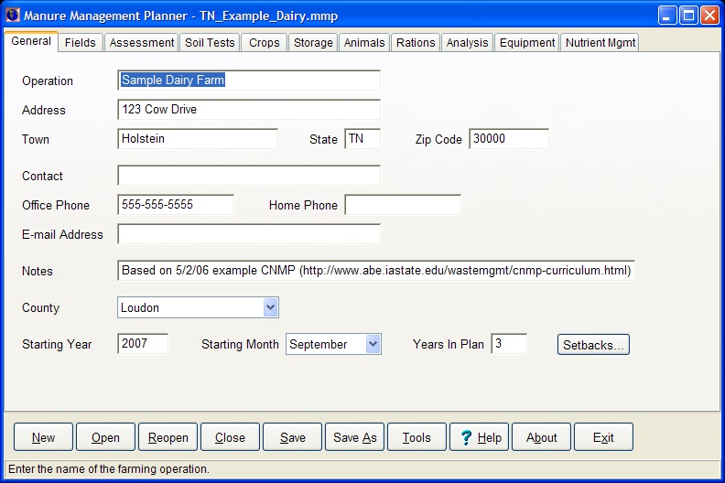

3.4. Ten steps to getting started quickly with MMP
1. Use MMP's help whenever you're uncertain about what to enter or how to proceed. Just press the F1 key to get help for the current command button, data panel, or dialog box. With a dialog box, you can also click its Help button. To see a list of major help topics, click the Help button at the bottom of MMP's main window.
2. Click the New button at the bottom of MMP's main window to create a new manure management plan for entering your own plan data. Click the Open button to resume editing a previously saved plan.
3. Once you've created a new plan or opened an existing plan, MMP displays the plan's General data panel, the first of several panels where you'll enter plan data. On the panel are input boxes where you enter data. Press the Tab or Enter key to move to the next input box and Shift+Tab to move to the previous input box, or click on an input box to jump to it. When you move to a different input box, MMP displays information about the input box on the status bar at the bottom of the main window.
4. At the top of the panel are tabs labeled General, Fields, Soil Tests, and so on. Click on a tab to view its corresponding data panel.
5. Enter as much data as you can for your plan. You can always come back later and fill in the rest.
6. To save your plan to a file, click the Save button. To save your plan under another name (for example, to save a previous version or backup copy of your plan), click the Save As button.
7. To check your data, click the Tools button and click Check Plan's Data For Completeness on the Tools dialog box's Reports panel.
8. To generate a report showing your fields' nutrient needs, click the Tools button and click Report Annual Field Nutrient Needs.
9. Use the Nutrient Mgmt panel to plan manure applications, manure transfers, and commercial fertilizer applications for each year in the plan.
10. To generate a report showing your fields' nutrient balance as a result of the planned manure and fertilizer applications you entered on the Nutrient Mgmt panel, click the Tools button and click Report Field Nutrient Balance.
3.5. Quick tips on entering data
1. F1 for help. If in doubt about what to enter, press the F1 key to display help for the current data panel or dialog box. If you don't know how to use help with Windows, press the F1 key from within help.
2. Status bar hints. When entering data, the status bar at the bottom of the main window displays a brief description of the type of data expected for the current input box or grid column. If in doubt about what to enter, glance down at the status bar for a hint.
3. Undo. To undo typing changes that you've made to an input box, press Ctrl+Z. Note that this works only if you haven't moved from the input box. You can also right-click on the input box and choose Restore from the popup menu to undo typing changes.
4. Copy and paste. To speed up entering the same data into several different input boxes, press Ctrl+C to copy the highlighted contents of an input box to the Windows clipboard. Then move to a different input box and press Ctrl+V to paste the clipboard contents into that input box. You can also right-click on an input box and choose Copy or Paste from the popup menu.
5. Operating a pick list. To pull down a pick list with the mouse, click the arrow on the right side of the pick list box. To close the pick list without selecting anything, click the arrow again or click anywhere outside the pick list. With the keyboard, press Alt+↓ to pull down the list. Press Alt+↓ again to close the list.
6. Pick list shortcut. To speed up entering data with a pick list, type the first letter of the desired item's name to select the first item that starts with that letter. If there's more than one item starting with that letter, you can continue typing that letter to cycle through the items. Note that this works even if the list is not pulled down. For example, when selecting crops, you can simply type C to select Corn without even pulling down the list. (When cycling through the list, don't pause between keystrokes. If you pause, the search is reset. Also, if you type quickly, you can continue typing additional letters of the desired item to jump to it. For example, quickly type CR to select CRP.)
7. Blanking out a pick list. To blank out a pick list box, scroll to the top of the list and choose the first item, which will either be blank or, if the pick list is in a grid, (None). With a grid pick list, you can also just press the spacebar to select (None) without pulling down the list.
8. Sorting a data entry grid. To sort the Fields, Soil Tests, Storage, Animals, Analysis or Equipment grid, simply right-click on the header row of the column you want to sort the grid by and choose Sort Ascending or Sort Descending from the popup menu.
9. Deleting or inserting a field. To delete a field or insert a new field, on the Fields panel right-click the indicator column (») of the field you want to delete or the row where you want to insert a new field. Choose Delete Field or Insert Field from the popup menu.
10. County. In the County pick list, be sure to select the county where the crop fields are located, not the county of the operation's mailing address.
11. Irrigation. Since irrigation affects fertilizer recommendations in some states, be sure to indicate if a field is irrigated by checking the Irrigation column for the field on the Fields panel.
12. Cover crop. If a field will have a non-harvested cover crop, scroll to the right on the Crops panel and select it in the Planned Cover Crop column for each year that it will be planted. Do not enter a yield goal. Note that fall-seeded single-cropped small grains that will be harvested the next year should be selected in the Planned Crop column.
13. Proofing data. Enter as much of the operation's data as you can, then click the Tools button and click Check Plan's Data For Completeness to see if any required data is missing or if there are any inconsistencies in what you've entered. To check if you've entered enough soil test data, look at the Default N Rec, Default P2O5 Rec and Default K2O Rec columns on the Crops panel. If any of these is blank for a crop, then some of the field's soil test data (or the crop's yield goal) is missing.
14. Close button to back out. Click the Close button to abandon any changes that you've made since the plan was last saved. You can use this the same way you use the File | Close menu command in a word processor or spreadsheet.
15. State-specific notes. Be sure to review any notes specific to your state. Click the State-Specific Notes topic in MMP's help.
16. Frequently Asked Questions (FAQs). Read through the list of FAQs in MMP's help or MMP's Web site. The first time you read them, some questions or answers may not make much sense to you. Go back and read them again after you've used MMP for a while. To print a copy of MMP's FAQs or any other help topic, select the help window's File | Print Topic menu command.
17. Reporting problems. If you have questions about MMP or problems operating it, please contact the authors. Click on the Reporting Problems To The Authors topic in MMP's help for contact information. Contact information is also available on MMP's Web site.
18. Making screenshots. To take a shot of the current MMP window or dialog box and paste the shot into a PowerPoint or Word document, press Alt+PrntScrn. To take a shot of the entire screen, press PrntScrn. This copies the window or screen contents to the Windows clipboard. In PowerPoint or Word, press Ctrl+V to paste the screenshot into the document.
4. Risk Assessment
As part of developing a nutrient management plan, you need to assess the risk of soil and nutrients leaving the field. You estimate soil loss with the Revised Universal Soil Loss Equation version 2 (RUSLE2) software, which is integrated into MMP. You assess the risk of phosphorus loss from the field with your state's Phosphorus Index (PI) or other risk assessment procedure. Phosphorus risk assessment tools for a number of states are included with MMP.
Since many phosphorus risk assessment tools require an estimate of soil loss as one of their inputs, let's start with RUSLE2.
4.1. Obtaining a RUSLE2 database
Before you can use MMP's built-in RUSLE2, you must create or obtain a RUSLE2 database (.gdb extension) for use with your plan. This database must contain the correct climate, soil and crop management data for the farm's area or you won't be able to select the appropriate RUSLE2 data in MMP.
The recommended way of creating a RUSLE2 database for your plan is to use the following Web-based "clipper" application to locate your plan's farm and clip out and download data for the area around the farm:
http://nmplanner.missouri.edu/software/national_data.asp
This "clipping" automatically creates a RUSLE2 database for the farm's area that can be used with MMP. Simply extract and move the .gdb file that's included in the downloaded .zip file to the same folder as your plan file and rename it so that it has the same name as your plan file, but with a .gdb extension.
Example: You've downloaded file MyFarm.zip created by the clipper app to use with your JonesFarm.mmp plan. Extract file MyFarm_RUSLE2mosesdb.gdb from MyFarm.zip and rename it to JonesFarm.gdb. Also move JonesFarm.gdb into the same folder as JonesFarm.mmp. (Note that if you're using the downloaded .zip file with a GIS, your GIS software may have already extracted and renamed the RUSLE2 .gdb file for you automatically.)
Tip: Refer to MMP's help for other options if you can't use the Web clipper app to create your RUSLE2 database.
4.2. Entering RUSLE2 data
Once you have a RUSLE2 database (.gdb extension) for your plan, open the plan and click the RUSLE2 button at the top of the Crops panel. This brings up MMP's RUSLE2 Data Editor, where you enter RUSLE2 data for the plan, fields and crops.
The RUSLE2 Data Editor looks like the screenshot on the next page. Click the Help button for assistance on how to use the RUSLE2 Data Editor.
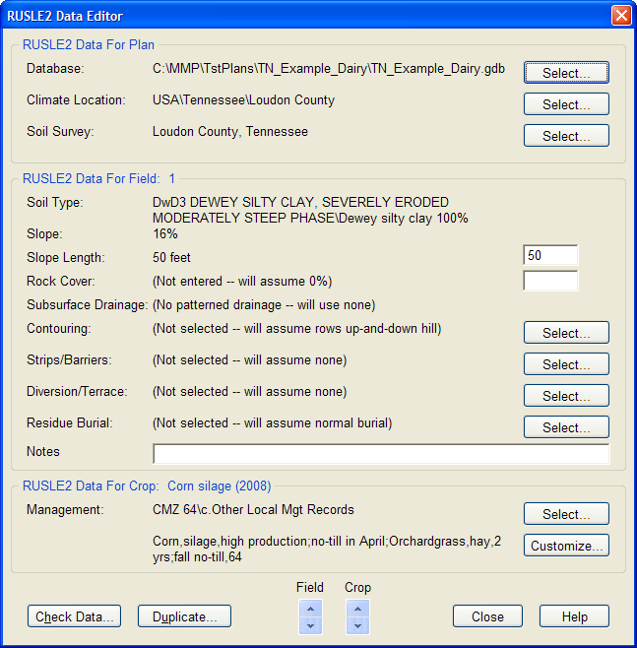
When you click one of the Select buttons, MMP displays a list of choices that you select from. These choices come from the RUSLE2 database indicated at the top of the dialog box. Many of these choices are self explanatory and you can leave several of them unselected if they don't apply to a field. An exception is the choice for each crop's Management, which must be selected for all fields.
4.3. Selecting a crop's management
In RUSLE2, a "management" is the sequence of expected field operations that will be performed for one or more crops. Field operations include planting, tillage and harvest operations, as well as any planned manure applications.
All managements are stored in the plan's RUSLE2 database (.gdb extension). Your RUSLE2 database includes a number of "canned" managements that you can select from when you click the Select button. You can also create your own "custom" managements by clicking the Customize button. Managements can be for single crops, in which case you would select a management for each plan crop; managements can also be for multiple crops and/or years, in which case you would only select a management for the plan crop that corresponds to the first crop in the management.
4.4. Creating a custom management
In the previous screenshot, the management selected for the first crop year of field 1 is a custom, multi-year management that covers the field's entire 3-year crop rotation. It was created using MMP's Custom Management Editor, which is displayed when you click the Customize button. When opened, this custom management looks like what you see in this screenshot:
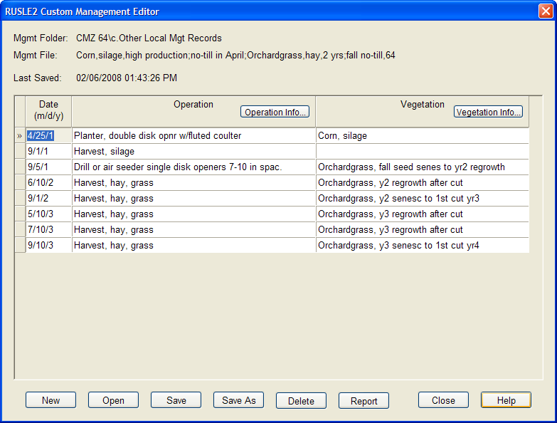
For help with operating the Custom Management Editor, click the Help button. However, there are several things about this particular management that are worth noting:
- The year in the dates is the calendar year of the operation relative to the start of the management, so 1 is the first year, 2 is the second year, etc. Don't confuse this with MMP's crop year, which will span two calendar years when there are fall operations. In this example, the orchardgrass seeding is part of what MMP considers crop year 2 even though it occurs during calendar year 1. Crop year 2 also includes the two hay cuttings in calendar year 2.
- The year in the forage descriptions also refers to calendar year, so that "y2 regrowth" refers to the amount of regrowth that occurs after the first harvest in the second calendar year.
- Since this is a no-till field, its management does not have any tillage operations.
4.5. Checking RUSLE2 data
To see if a field's RUSLE2 data is complete, click the Check Data button in the RUSLE2 Data Editor. MMP will check if all required data for the field has been entered and then attempts to calculate soil loss for the field. If it finds any problems, MMP will display an error message; otherwise, it will display the complete list of operations for all of the field's crops, as well as the soil loss for each crop year, as in the following screenshot:
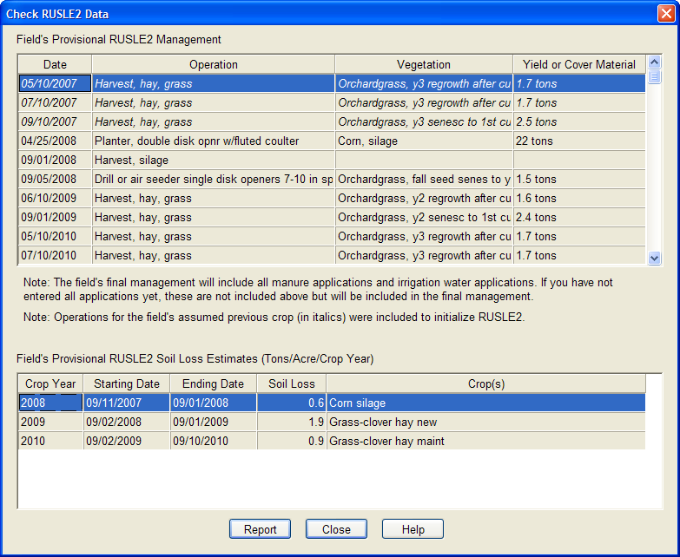
A few things worth noting about this example:
- Since field 1 does not receive any manure, no manure operations are included in the list. To see an example with manure applications, click Check Data for one of the continuous silage fields in the plan that will receive manure.
- Based on the field's rotation, MMP assumes that this field was in hay in the year prior to the start of the plan and inserts that crop's operations (shown in italics) at the beginning of the list in order to initialize RUSLE2.
- Note that even though this field has a steep slope, its soil loss estimates are quite low due to the residue left by the hay crop, which is only minimally disturbed by the no-till planting.
4.6. Entering other assessment data
Make sure you've entered all data required by your state's phosphorus risk assessment tool on the Assessment panel. For information about what data is required by your state's assessment tool, click MMP's Tools button, click the Custom tab on the Tools dialog, then double-click the "Notes" item in the group for your state's risk assessment tool. For example, with this example plan, you would double-click "Notes on Using the Tennessee Phosphorus Index Tool." This opens the notes document in Microsoft Word. This document may also include hyperlinks to additional Web-based documentation for the state's risk assessment procedure.
Important! MMP may not yet include a risk assessment tool for your state. In that case, you can still enter the assessment data on the Assessment panel for completeness, but you will also need to enter the data in the risk assessment tool provided by your state (typically an Excel spreadsheet). Please refer to your state's risk assessment tool and its documentation for more information.
4.7. Running the phosphorus risk assessment tool
Once you've entered enough RUSLE2 and assessment data for your plan's fields, you can run MMP's phosphorus risk assessment tool by double-clicking the appropriate report on the Tools dialog's Custom panel. If it can't calculate the risk assessment for a field, the tool will include an error message at the bottom of the report.
Note that you can run the risk assessment tool even before you've planned any nutrient applications in MMP. This can be useful for determining a field's "baseline" or inherent level of risk without the application of additional nutrients.
Note: When you generate a CNMP or other plan document, MMP will automatically run your state's phosphorus risk assessment tool and insert the resulting table into the document. For more information about generating a plan document, refer to Section 7. MMP also runs your state's phosphorus risk assessment tool in its rate calculator when determining the "Maximum allowable rate" choice. For more information, see Section 5.
5. Allocating Manure with MMP
Let's first review the general steps involved in developing a plan with MMP:
1. Enter the operation's data on the General through Equipment panels. If the operation does not have any livestock or manure, you only need to enter data on the General through Crops panels. If the operation does not have any livestock but will be importing manure, enter data on the General though Storage panels and on the Analysis and Equipment panels, but not on the Animals and Rations panels.
2. Run the Check Plan's Data report to make sure you've entered enough data. If necessary, keep entering data until this report indicates that the plan's data is complete. You can also run this report after each of the remaining steps to make sure that you entered enough data for that step.
3. If the operation will export or import some of its manure, enter these manure transfers on the Nutrient Mgmt panel in the expected months so the manure inventory is complete. (Select the storage and transfer month by clicking on a cell in the Storage Status grid and press F2, or just double-click the cell. This brings up the Manure Transfer Editor.)
4. Enter any starter fertilizer or irrigation water applications and make sure you check the Include Fertilizer When Calculating Field's Manure Application Rate box in the Fertilizer Application Editor. (Select the field and application month by clicking on a cell in the Field Status grid and press F2, or just double-click the cell. This brings up the Fertilizer Application Editor.)
5. Allocate manure to fields that can receive manure based on a strategy you develop with the producer (covered in Section 6). Enter these applications in the Manure Applications grid at the bottom of the Nutrient Mgmt panel. Click the Calc button to bring up the Manure Application Rate Calculator.
6. Export any leftover manure. If manure can't be exported, you will need to revisit step 5 and make sure all manure is applied.
7. Enter supplemental fertilizer applications to meet deficits (usually N) on fields that received manure and to meet nutrient needs on fields that did not receive manure and on any non-spreadable areas of fields.
Entering most of the information required by MMP is fairly straightforward, involving the tracking down and entry of standard field and animal inventory data. An exception is the Nutrient Mgmt panel, where you have to make decisions about the operation's planned manure and fertilizer applications. The Nutrient Mgmt panel for the sample TN_Example_Dairy.mmp plan included with MMP looks like the screenshot on the next page before any applications have been planned.
The Nutrient Mgmt panel contains three grids:
1. The Storage Status grid at the top shows the monthly inventory status of the storage facilities that you defined on the Storage panel. If a number in a storage cell is underlined and in red, this indicates that the anticipated manure available by the end of that month will exceed the facility's capacity. Green indicates the facility's capacity is sufficient for the amount of manure available.
Tip: You also access the Manure Transfer Editor from the Storage Status grid by clicking one of its cells and pressing F2, or by just double-clicking one of its cells.
2. The Field Status grid in the middle shows the monthly manure status of the crop fields that you defined on the Fields panel. It also shows if a field has any fertilizer applications, indicated by F in each application month's cell.
Tip: You also access the Fertilizer Application Editor from the Field Status grid by clicking one of its cells and pressing F2, or by just double-clicking one of its cells.
Note: If you've entered RUSLE2 managements for a field's crops, the Field Status grid also shows each crop's planting month (P), harvest month (H) and any tillage months (T).
3. The Manure Applications grid at the bottom shows the planned manure applications for the currently selected month and storage (or field) in the two upper grids. You edit existing applications, or enter new applications, by clicking on a cell in one of the two upper grids, then clicking on the bottom grid to edit the manure application data.
The purpose of the Nutrient Mgmt panel is to plan manure applications for your crop fields, keeping the storage inventory numbers green for the length of the plan. You also plan manure transfers (exports, imports, etc.) and commercial fertilizer applications on this panel.
Important! Normally you enter all planned starter fertilizer applications before planning any manure applications. For help with entering fertilizer applications, access the Fertilizer Application Editor from the Field Status grid (double-click one of its cells) and click the editor's Help button.
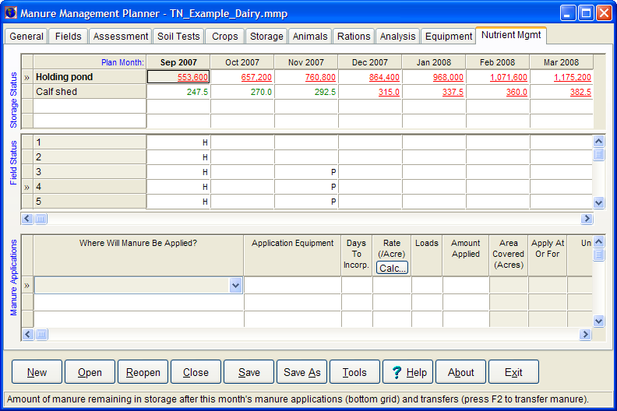
Here are the steps for entering planned manure applications:
1. Click on the desired storage month in the top grid or the desired field month in the middle grid.
When a storage cell in the top grid is highlighted (as in the illustration above), the first column in the bottom grid contains a pull-down list of fields that you select from.
When a field cell is highlighted in the middle grid, the first column in the bottom grid contains a pull-down list of storages that you select from.
2. Select a field or a storage in the first column of the bottom grid. Note that by default the pull-down list of fields is ranked by application priority. With fields that are candidates for manure application that month, the crop that the manure will be fertilizing appears in parentheses after the field ID. Fields that are not candidates for manure application that month fall to the bottom of the list; the reason why a field should not be manured that month appears in brackets following the field ID.
Tip: To change the way that fields are ranked in the list, right-click the indicator column (») at the left side of the bottom grid to display a popup menu and choose Rank Field List By. The current rank order will be checked. Choose a different rank order to change the field list ranking.
3. Select the equipment in the Application Equipment column.
4. Enter the number of days until the manure will be incorporated in the Days To Incorp. column, or leave blank if the manure will not be incorporated or if the manure will be injected.
5. In the Rate column, click the Calc button or press the F2 key to display the Manure Application Rate Calculator.
Tip: If you want to use your own application rate, enter the custom rate in the Rate column before clicking the Calc button or pressing the F2 key.
Tip: To delete a manure application, right-click on the indicator column (») at the left side of the grid to display the popup menu, then choose Delete Application.
The Manure Application Rate Calculator looks like this for Tennessee plans:
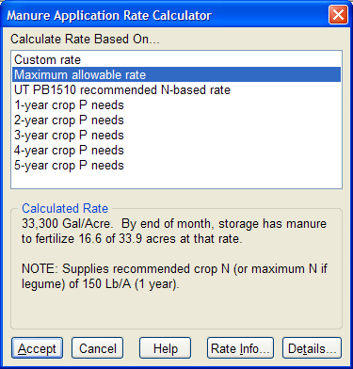
6. In the Calculate Rate Based On list box, select the basis you want to use for the rate calculation. If the plan data required for the calculation is complete, MMP calculates and displays the rate and enables the Accept button; if any required data is missing, MMP indicates what's missing and disables the Accept button.
Important! With the "Maximum allowable rate" basis, MMP uses the state's phosphorus risk assessment tool to determine automatically the highest rate that is acceptable to the tool. This rate will never be higher than the N-based rate.
Tip: If you need more information about the listed application rate choices, click the Rate Info button.
Tip: To review what manure and fertilizer applications have been made so far to this field, click the Details button.
7. Click the Accept button to insert the calculated application rate and number of loads to apply into the Rate and Loads columns in the bottom grid on the Nutrient Mgmt panel. This also updates the storage and field status in the top two grids. Note that MMP now displays the storage-month's amount of remaining manure in bold to indicate that at least one application is planned for that storage and month. Also, once a field has been completely manured, MMP changes the background color of the field's cells to red to indicate that the field should not receive any more manure during the indicated months.
8. Repeat these steps for each planned manure application through the end of the plan.
6. Developing a Manure Allocation Strategy
The previous section discussed how to operate MMP to allocate manure. This section discusses how to develop a strategy for deciding what fields will receive manure and when to apply manure to those fields.
Important! Developing a manure allocation strategy requires an in-depth understanding of the operation and the producer's preferences, as well as knowledge of state-specific restrictions and guidelines on manure applications.
MMP includes a number of sample plan files for several states in its Samples folder. You can open the IN-Pig1.mmp sample plan for Indiana to follow along with the discussion below. This plan file's operation data is complete, but no manure has been allocated and no fertilizer has been applied yet.
6.1. Producer preferences
First consider the operation's application restrictions and producer preferences. While plan IN-Pig1.mmp is entirely fictitious, let's assume that the producer has indicated the following about his operation:
- With the operation's corn-soybean rotation, assume that no manure will be applied during June-August.
- Assume that at least one field coming out of soybeans will be available for spreading in September.
- Assume that fields coming out of corn will not be available for spreading until October.
- Assume that March is usually too wet for spreading on any of the operation's fields.
- Assume that the producer usually has enough time in winter (December-February) to haul manure to the Smith fields that are 3.5 miles from the storage pits, but not enough time in fall or spring to do this.
- Assume that the Mueller field, at 7 miles from the storage pits, will never be manured. (In the sample plan, this field's Will Not Receive Manure box is checked on the Assessment panel. This field appears in the Field Status grid so you can apply fertilizer to it, but you won't be able to apply manure to it.)
- Assume that the producer can manure 20 acres in September, 60 acres each in October and November, 40 acres in December, 20 acres each in January, February and April, and 40 acres in May.
6.2. Risk assessment tools
Next run any state-specific phosphorus index or other risk assessment tool. In Indiana, this is the Offsite Risk Index (ORI) tool, which can help identify additional field-specific concerns. In other states, the phosphorus index or other state-specific assessment tool may be used to set the rate basis, set rate limits, or flag fields that should not receive any manure. The correct tool to use will depend on the state you are developing the plan for.
Indiana's ORI tool planning calendar indicates the following about the sample operation's fields:
- Based on soil type, the Home fields are flood-prone during November and January-June, so apply manure to those fields only in September and October.
- Five of the fields have a slope greater than 2%, so avoid applying manure to those fields in winter. This includes two of the Smith fields that were to be used for winter spreading. With another of these fields (Pop's 20), erosion is also a concern, so avoid spring applications to that field as well.
- Let's assume that distance to water and subsurface drainage are not concerns with any of the fields.
6.3. Application guidelines
Finally, look at the state NRCS 590 standard and related documents for guidelines and restrictions on manure application. In Indiana, the NRCS 590 standard's guidelines indicate the following about the sample operation's fields:
- With one field (Home 60 S20), manure should be applied on a 1 x P removal basis because its soil test P level is in the 101-200 ppm range.
- With five other fields, manure can be applied up to a 1.5 x P removal basis because their soil test P levels are in the 51-100 ppm range.
- With the remaining fields, manure can be applied on a nitrogen basis since their soil test P levels are in the 0-50 ppm range.
MMP's initialization file for Indiana includes rate calculations for all of these cases. For other states supported by MMP, the state initialization files will include the appropriate rate calculations you'll need.
Tip: It's a good idea to document the allocation strategy you'll be using for each field in the Notes columns on the Fields and Soil Tests panel. See sample plan IN-Pig2.mmp for an example of how to do this.
6.4. Other useful items
At this point, you should have enough information to start allocating manure to the plan's fields. However, before you start it will probably be useful to have the following items handy:
- A map of the operation's fields. With the sample plan, you can open or print the simple map in document PigMap.doc in MMP's Samples folder.
- A planning calendar. Indiana's ORI tool can generate a monthly calendar that includes the fields' concerns. For other states, you can run the Planning Calendar 1 custom report under the Manure Application Planning Calendars on the Custom panel of the Tools dialog. Once printed, you can manually block out any months when manure should not be applied.
- You may find it helpful to write down some of the guidelines you developed in the preceding subsections. For example, a list of fields grouped by rate calculation might be handy to refer to when deciding what application rate to use for a field.
6.5. Some common sense suggestions
- As in Indiana, many state guidelines permit the application of enough manure to meet multiple years of P as long as the rate does not exceed the crop's N need and the field is not manured again for the targeted number of years. With fields that can receive more than one year of P, it usually makes sense to put on as many years as allowed. You won't use up any more manure during the plan this way, but it will reduce the number of fields that have to be manured in any given year. This will also increase the application rates, meaning you won't be using the equipment's minimum application rate as often.
- Haul the most concentrated manure to the fields that are farthest away from the storage to reduce the number of loads that need to be hauled to those fields.
6.6. Allocating manure
Depending on the operation, you may want to select the storage first, then the field from the manure application grid's pick list, or you may want to select the field first, then the storage. With the sample plan hog operation, storage capacity is always a concern, so it probably makes sense to pick a storage that you want to empty and then pick a field where that storage's manure should go. With operations where storage capacity is not so much of an issue (e.g., poultry operations), it might make more sense to pick a field and then apply manure to it as necessary through the end of the plan before moving on to the next field.
Note that you can change the order of fields in the manure application grid's pick list. Right-click the grid's indicator column (») and choose Rank Field List By, then select how you want the fields ranked. To utilize the Plan Field Order choice, go back to the Fields or Soil Tests panel and sort the fields by one of those panels' columns. For example, to pick from a list of fields ranked by soil test P level, right-click the P column header on the Soil Tests panel and choose Sort Ascending from the popup menu. Back on the Nutrient Mgmt panel, the field pick list will now be ranked by soil test P, from lowest to highest.
At any point in your allocation, you can review all of the planned applications you've made so far by running the Manure Management Plan Data Report under the Standard Custom Reports on the Custom panel of the Tools dialog. You can also re-run the planning calendar mentioned above whenever you want to see how many loads you're planning to haul each month.
6.7. Assessing the planned allocation
After you've practiced allocating manure for the sample plan according to the above guidelines, open sample plan IN-Pig2.mmp and review its planned manure applications. This plan file has the same data as IN-Pig1.mmp, but with all of its manure allocated according to the guidelines discussed above. With any plan, the first thing you might do is run the Check Plan's Data report again to make sure you didn't make any mistakes allocating manure (e.g., applying solid manure with a liquid spreader, etc.).
Next compare each storage's inventory in the last month of the plan with the amount of manure on-hand at the start of the plan. The ending inventory should be less than or equal to the amount on-hand at the start of the plan. If it's significantly higher than the starting amount, you're probably not utilizing enough manure in the plan.
Next run the Nutrient Balance, Nutrient Status, and Projected Soil P And K Levels reports to assess the impact of planned manure applications on supplemental fertilizer needs and soil fertility levels. Also, run the Charts Of Planned Manure Applications custom reports to see the number of loads and driving miles required by the sample plan – looking at these charts is a good way to determine if a plan can pass a "reality check" for feasibility.
Consider whether exporting leftover manure would be useful for drawing down manure inventory and creating some flexibility for operations with limited storage systems. For example, sample plan IN-Pig2.mmp demonstrates that there's enough land and spreading time to handle all manure produced, even drawing down the inventory a bit over the course of the plan. However, this plan assumes that manure will be spread during eight months of the year and that practically every available field will receive manure. It doesn't provide much flexibility if wet soil conditions or other factors prevent manure from being applied for a month or two. Furthermore, it assumes that a lot of manure can be applied during some months and that a lot of miles can be driven during the winter. Annually exporting a portion of the manure to a neighbor could allow the pits to be emptied more completely, thus providing a buffer should weather later in the year prevent manure from being applied.
Exporting some of an operation's manure may also help keep soil test P levels from increasing. Again, although sample plan IN-Pig2.mmp shows that all manure can be utilized on the operation, this plan may not be sustainable over the long haul. The Projected Soil P And K Levels report indicates that, while the fields being managed on a P basis may not show much of an increase in P over time, some of the fields currently being managed on an N basis may also need to be managed on a P basis if the next round of soil sampling shows soil test P increases for those fields in line with what the report projects.
Refer to sample plan IN-Pig2x.mmp for an example of how exporting can be used in managing manure. In this sample plan, the producer exports part of his manure each year in late fall to a neighbor. This allows him to eliminate most winter applications and almost completely empty his largest pit after exporting in the third plan year.
7. Using MMP to Generate Reports and Documents
MMP includes several useful built-in reports that you can run, as well as numerous custom reports and tools that you can use if you have Microsoft Office installed on your computer. To see the list of built-in reports, click the Tools button in MMP and then click the Reports tab in the Tools dialog box. To see the list of custom reports for the currently open plan's state, click Tools and then click the Custom tab.
7.1. What you'll need to generate reports
You don't need any additional software or files to view and print MMP's built-in reports. Just click the report's button on the Reports panel in the Tools dialog box. However, to run a custom report or tool, you'll need two things:
- Custom report files. Many of these custom reports are distributed and installed with MMP. If you don't see a custom report that you think is included with MMP, you may need to re-run MMP's installer and select the missing custom report.
With custom reports and tools developed by other states, you'll need to obtain the custom report files and copy them to MMP's Custom folder. The next time you create or open a plan file for that state, you'll see the state's custom reports on the Custom panel.
- Software that the custom report requires. MMP displays the name of the required software in the Requires box on the Custom panel. For example, as illustrated below, the Chart Of Distance Traveled While Applying Planned Manure custom report requires Microsoft Access 2000, 2002 or 2003.
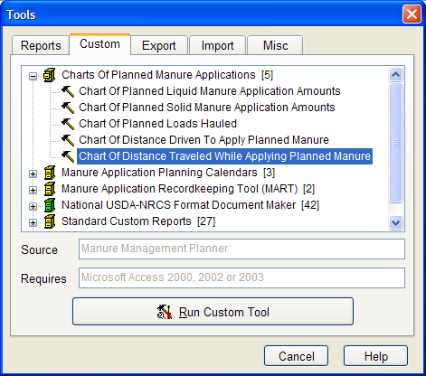
7.2. Built-in reports
On the Tools dialog's Reports panel, click the button of the report you want to view:
- Check Plan's Data For Completeness. Click this button to view a report that lists any missing values or inconsistencies in the plan's data.
- Report Annual Field Nutrient Needs. Click this button to view a report that lists each field's nutrient needs for each year in the plan.
- Report Field Nutrient Balance. Click this button to view a report that summarizes the net effect of planned nutrient applications for each field. This report shows only the nutrient balances at the end of each year and not the individual nutrient applications.
- Report Field Nutrient Status Details. Click this button to view a detailed report that shows the effect of planned nutrient applications for each field. This report shows individual nutrient applications as well as the nutrient balances at the end of each year.
- Report Projected Soil P And K Levels. Click this button to view a report that shows projected soil P and K levels at the end of the plan, based on crop removal rates and planned manure and fertilizer applications.
Tip: Check the View Report With Word box on the Reports panel before clicking a report button to open the report in Microsoft Word, where you can view, edit, print and save the report. If you leave the box unchecked, MMP opens the report in its Preview dialog box, where you can view, print or save the report, but not edit it.
7.3. Charts of Planned Manure Applications
Run one of these custom reports to see your planned manure applications in graphical form.
7.4. Manure Application Planning Calendars
MMP includes two planning calendars that you can generate for any plan:
- Planning Calendar 1 (Compact Report Of Loads By Month). Run this custom report to generate a compact monthly calendar for each year in the plan. If you've allocated manure for the plan, the number of planned loads for each month will appear on the calendar.
- Planning Calendar 2 (Detailed 12-Month Document). Run this custom tool to generate a 12-month daily calendar in the form of a Microsoft Word document. A table of each month's planned application data will appear with each month's calendar, as well as a blank form for recording actual manure application data. Once printed, producers can use this calendar to see what applications are planned for each month, as well as to record data about each actual manure application. If saved to a file, this document can also be used as a simple computerized recordkeeping system by entering the actual manure application data using Word.
7.5. Manure Application Recordkeeping Tool (MART)
Recordkeeping requirements for manure applications differ from state to state. Many states have paper-based recordkeeping systems you can use. MMP includes an Access-based custom recordkeeping tool that may meet your needs for manure application, fertilizer application, and manure export records.
For more information, refer to the "Overview of Manure Application Recordkeeping Tool" document in the tools list.
7.6. National USDA-NRCS Format Document Maker
Once your MMP plan is complete, run the appropriate tool from this list to generate a Comprehensive Nutrient Management Plan (CNMP) or other plan document in the NRCS national format. MMP opens the generated document in Microsoft Word so you can edit it and insert other required information. See the instructions for information on completing the document once it has been generated.
Tip: When generating a CNMP or other plan document, MMP looks for a file with the same name and in the same folder as your MMP plan file, but with a .consplan.xml extension. If it finds this file, it will use it to generate the conservation plan tables in the document. You create this file with the software that you used to create your plan's conservation plan. Be sure to create this file before generating the CNMP or other plan document. For more information, refer to "Instructions for Generating and Completing Documents" included at the top of the tool list.
Note: MMP uses a custom tool called Document Maker to generate these plan documents. For more information, click the Help button on the Document Maker dialog box that appears when you run the tool.
7.7. Phosphorus Index (or other risk assessment tool) [if available for state]
Run this custom tool to generate a report for your state's risk assessment tool. The tool adds environmental assessment capabilities and reports to MMP.
For more information about the tool, refer to the tool's documentation in the custom tool list. The documentation will indicate any additional data required by the tool that needs to be entered on MMP's Assessment panel.
7.8. Standard Custom Reports
These custom reports provide ways of summarizing all of a plan's data or a state's initialization file data.
8. Solving Common Planning Problems
This section is about how to decide what data to enter. It's not about how MMP operates. For help with that, refer to Sections 3, 4 and 5 in this guide and MMP's help.
8.1. Picking an appropriate starting year, starting month, and plan length
A plan's starting year, starting month, and length determine the period of time that the plan is designed for. Normally you select a future date for the start of the plan, or a date in the recent past if no manure has been applied since then.
Pick a month so you can plan all manure applications intended for the first crop. For example, if no manure will be applied during the growing season until September, then September would be a good starting month. You can also start the plan in winter or spring if no applications will be made the previous fall.
In general, your plan should be long enough to handle your longest crop rotation. If almost all of your fields are on a two-year rotation, you might be able to do just a two-year plan, since there will be few differences between years 1 and 3 or 2 and 4. If you have fields that are on a three- or four-year rotation, you will probably want to have a longer plan. A five-year plan is useful if you want to see what the projected impact of manure application will be on soil test levels after a couple of rotations. Some states may require a specific plan length.
Note: Rotations that include alfalfa may be more than five years in length. However, creating a plan that's long enough to accommodate these rotations may be impractical. If this is the case, you can use a shorter plan length, but keep in mind that MMP may not be able to determine the previous crop (for the year prior to the start of the plan) for fields in these rotations since it doesn't know what the complete rotation is. Refer to Section 8.5 below for more information on how to address this problem.
8.1.1. "Rolling over" data to a future plan
You can also change a plan's starting date when you need to create a new plan based on an existing plan. Simply open the existing plan and change the starting year and month to what you want for the new plan. MMP will prompt whether you want to leave crop years and application months unchanged. You have two choices:
- Yes : Let MMP delete any crops, manure applications, manure transfers, and fertilizer applications that are outside of the plan's new period, but leave data that is inside the new period alone.
- No: Let MMP renumber all crop, manure application, manure transfer, and fertilizer application years based on the plan's new starting date. No data is deleted.
If you just want to advance the plan and delete any data prior to the new starting date, choose Yes. For example, if you have a three-year plan and after one year you need to revise it, all you need to do is increase the plan's starting year by one and choose Yes. MMP will delete the first year's data and create space for a new third year where you enter the new data.
If you just want to use the same data but with different years, choose No. For example, if you have a two-year plan and after two years you want to create a new two-year plan that is very similar to the old plan, all you need to do is increase the plan's starting year by two and choose No. MMP will simply renumber the data's years using the new starting year. You can then make any changes you need to the plan's data.
In both cases, click the Save As button to save the modified plan file under a different name so you preserve the old plan file.
Tip: You can also add years to an existing plan. For example, to add a year to the end of a plan, just increase the plan length by one. To add a year to the beginning of a plan, just increase the plan length by one, then decrease the starting year by one and choose Yes when prompted.
8.2. Determining driving distance from storage to field
Determining the driving distance from a manure storage to a field can be tricky if the route isn't on established roads. However, if you have a map based on an aerial photo (like what GIS software creates), you can easily find and measure the route. It's helpful if you can locate a ruler that's marked off in tenths of an inch instead of sixteenths the way most rulers are.
If the aerial photo is of sufficient resolution (for example, 1 meter per pixel), you should be able to see not only the farm's buildings, but also driving lanes through fields as well as paved and unpaved roads. If the map was created your GIS software you'll see the drawn field boundaries too.
Determine the distance that corresponds to each tic mark on the ruler. For example, with a ruler marked off in tenths and a scale of 1" = 1 mile, then one tic is 1/10 mile. Then measure the length of each segment of the route in ruler tics, summing up the number of tics. For example, with this ruler and scale, a route that is 25 tics long would be a distance of 2.5 miles.
Use your best judgment in deciding what point to measure to in a field. For example, if you know where the gate is in a fence around a field, you could measure to that point. Or you could measure to the nearest point or to the center of the field. As long as you're consistent for all fields in a plan, your estimates will be useful in comparing relative differences between fields in driving distance.
8.3. Determining a field's soil type
If you used GIS software with a soil survey file to map the operation's fields, the GIS will automatically identify each field's soils and export this information to MMP. MMP will then automatically use the soil that encompasses the most acreage in the field. However, if you're not using GIS or if you're using GIS but don't have a soil survey file, you'll have to select each field's soil manually in MMP after looking at a published soil survey map. There are also cases where you may need to override the soil that the GIS identified for a field. The following points should help you in deciding what soil to select:
- If a field has more than one soil type, select the soil that's most important to you. Typically this is the soil with the most acreage in the field, but it could be the field's dominant critical soil type.
- With a soil complex, select the component of the complex that's most like the field's predominant soil.
- In a few cases, more than one soil survey may have been conducted in the plan's county. With these counties, MMP includes the soil survey ID with the soil map unit symbol in the soil pick list to distinguish between duplicate map units. Be sure to pick a soil from the appropriate survey for the field.
- Sometimes an operation's fields may span more than one county. With a field that's not located in the plan's county, select a soil that's similar to the one you want.
Example: After locating the field on the published soil survey map, you determine that its soils are made up of about 70% SwA (Starks-Fincastle complex) and 30% Md (Mahalasville-Treaty complex). You decide that SwA is more representative of the field since it makes up the most area in the field and also because its 1-3% organic matter is more typical of the field than Md's 3-6% organic matter. SwA is a complex and you decide that the areas of SwA in the field are more like its largest (first) component, Starks, rather than its secondary component, Fincastle. In MMP, you select SwA Starks as the field's soil and document in the Notes column why you picked this soil.
Tip: For fields that include two or more dissimilar soils, consider using your GIS to subdivide the fields based on soil type.
Tip: To generate a report with information about all soils in the plan's county, click the Soil Info button on the Fields panel.
8.4. Entering good soil test data
MMP generates a single fertilizer recommendation for each crop, based on a single set of soil test data. It's very important that you enter the right soil test data. If the soil test data isn't correct, the fertilizer recommendation probably won't be right either. Here are some tips for ensuring that the right soil test data is entered:
- Make sure the soil test extractions assumed by your state's Extension fertilizer recommendations were used by the soil test lab. Refer to the appropriate Extension publication to determine what extractions are assumed. This is particularly important with the phosphorus extraction, since soil test labs frequently offer more than one extraction for phosphorus. See also MMP's state-specific notes in the help for notes on this subject.
Tip: To find the name of the Extension fert rec publication, click the Crop Info button on the Crops panel. You can also click on a crop's Default Rec column on the Crops panel. MMP will display the source of the default recommendation on the status bar.
- If your state has different interpretations depending on the phosphorus soil test that was used, be sure to select the test that the lab used in the P Test Used column on the Soil Tests panel.
- Make sure you enter the right data from the soil test report. Labs often report the results in more than one way or report results from more than one extraction (particularly with phosphorus). The results may be labeled P1, P2, etc. Be sure you find out what extractions these labels refer to.
- Make sure you enter the soil test data in the correct units. With MMP, soil test data must be entered in units of elemental values (for example, elemental P, not P₂O₅). P, K, Mg, Ca and Na data can be entered in units of parts per million (ppm) or pounds per acre (Lb/A). If these values are Lb/A, be sure to check the Levels Are In Lb/A box on the Soil Tests panel. Refer to MMP's help if you need to convert soil test data to elemental values or between ppm and Lb/A.
- Make sure you enter enough data. Although you should always enter as much soil test data as possible, you really only need to enter what's required by your state's fertilizer recommendations. If a crop's default fertilizer recommendation is blank on the Crops panel, make sure you've entered enough soil test data for that crop's field.
- Make sure you use representative data. If you have more than soil test for a field (for example, from grid sampling), you will need to aggregate this data to come up with one set of data per field. If you are using other software to work with your soil test data (for example, site-specific software), that software may be able to aggregate the data for you. Otherwise, you can use the mean (average of a field's soil test values) or the median (middle value when the soil test values are ranked) as a representative value for that field. Be sure to document in the Notes column on the Soil Tests panel how you came up with the field's values.
8.5. Custom fertilizer recommendations
Occasionally there are times when you may need to override MMP's default Extension fertilizer recommendation with a custom recommendation. You do this by entering the custom rec in the appropriate Custom column on the Crops panel. Two cases where you might need to do this are discussed below.
Important! Anytime you enter a custom fertilizer recommendation, you should document how you came up with it in the Source column on the Crops panel.
8.5.1. Adjust the previous crop legume N credit
If a crop can take an N credit from the previous year's legume crop, MMP reduces the crop's N recommendation by the amount of the credit. MMP attempts to determine the previous crop for the first year of the plan by looking at the field's crop rotation. If your plan isn't long enough to encompass the entire planned rotation or if the planned rotation isn't the same as the field's historical rotation, MMP may not be able to determine the first year's previous crop correctly.
If this is the case, you can add or subtract the legume N credit from the value displayed in the first year's Default N Rec column and enter the result in the Custom N Rec column. This will override the Default N Rec value.
Tip: To determine the amount of legume N credit and whether a crop can take the credit, consult the source of MMP's N recommendation, which is displayed on the status bar when you click on the crop's Default N Rec column.
8.5.2. Account for previous manure credits
As the organic material in manure decomposes, it releases nitrogen that can be utilized by crops. Normally this process takes several years, meaning not all of the N from organic material in manure can be utilized in the first year following application. For many states, MMP automatically determines the amount of N credit that crops can take in the second and later years following a planned manure application and reduces the amount of N that needs to be supplied in those years. However, MMP has no knowledge of what manure, if any, was applied in the years before the start of the plan. If you have accurate records of where manure was applied prior to the start of the plan, when it was applied, the application rate and method, and the manure's nutrient analysis, you can account for these N credits by entering a custom N recommendation for one or more years at the start of the plan.
To do this for a crop year, first determine the amount of N that can be credited that year from each relevant application for which you have records. Subtract this amount from the value displayed in the year's Default N Rec column and enter the result in the Custom N Rec column. This will override the Default N Rec value.
Tip: To see the source of a state's manure N availability data, click on a planned manure application's Avail N As Applied column in the Manure Applications grid on the Nutrient Mgmt panel. The source will be displayed on the status bar. If no source is displayed it means the state does not take N credits from previous years' manure applications. You can also click the Storage Info button on the Storage panel and find the source in note 2 at the bottom of the report.
Tip: Frequently manure is applied to supply more than one year's worth of P and K. Again, MMP has no knowledge of any manure applied in the years before the start of the plan. If you have accurate records of prior years' manure applications, you can enter custom P₂O₅ and K₂O recs for one or more years at the start of the plan to account for these carryover credits. Typically you would enter 0 in the Custom P2O5 Rec and Custom K2O Rec columns if the crop year is within a multi-year application made before the start of the plan.
8.5.3. Account for previous P and K fertilizer credits
With many crop rotations, a single P or K fertilizer application supplies nutrients to more than one crop. For example, with corn-soybean rotations, P and K fertilizer for both crops is typically applied only every other year to the corn crop. However, MMP has no knowledge of what fertilizer was applied before the start of the plan. If you know that the fertilizer for the first crop in the plan (e.g., soybean) was applied to the previous crop (e.g., corn), you can enter 0 in the first crop's Custom P2O5 Rec and Custom K2O Rec columns.
8.6. Estimating storage capacity
You enter a pumpable or spreadable capacity on the Storage panel for each storage facility that you define. Generally the pumpable capacity is less than the storage's physical capacity. For example, you normally don't pump a lagoon dry, instead leaving a certain treatment volume at the bottom of the lagoon. This may be true with liquid pits as well if the operator is unable to empty the pits completely. And most storage facilities have a freeboard safety volume that should not be used for storage in normal situations. Reducing the storage's physical capacity by these volumes gives the pumpable capacity.
The engineering drawings for most storage facilities should include the storage's dimensions and volume. If you know a storage's dimensions but not its volume, you can use MMP's Storage Capacity Calculator to estimate the pumpable volume. This calculator is extremely simple and can be used only for a small number of regularly-shaped storage types. To display the calculator, press the F2 key in the Pumpable Or Spreadable Capacity column.
Tip: With new facilities you can use a design tool like the USDA-NRCS Animal Waste Management program to estimate the storage's pumpable capacity.
Tip: With outside stacks and facilities where storage capacity is not limited, enter a suitably large value for the storage's capacity so the storage won't ever be shown as exceeding capacity in the Storage Status grid on the Nutrient Mgmt panel. Be sure to document this in the storage's Notes column.
8.7. Estimating the amount of manure on hand at start of plan
On the Storage panel, you enter the amount of manure on hand at the start of the plan for each storage facility that you define. If the plan starts at a future date, you'll need to estimate how much manure will be in each storage on that date. This value should be the amount of pumpable or spreadable manure, which may be less than the actual amount of manure that will be in the storage if some of the manure will never be removed, as with lagoons.
There are several ways of coming up with a reasonable estimate:
- You can start the plan during a month when you know the storage will be empty, or full, or at a known amount.
- You can measure how much manure is in the storage now, then count the number of months between now and the start of the plan and add 1/12 of the storage's annual production (from the Analysis panel) for each month, subtracting any anticipated applications between now and the start of the plan.
- If the producer has good hauling records from the previous year, you might be able to reconstruct the amount that was available in each storage during the starting month in the previous year.
8.8. Seasonal differences in the amount of manure collected
There are several situations in which the amount of manure collected differs at various times during the year. This is usually due to seasonal changes in the number of animals whose manure is being collected.
For example, with dairy cows, some of the cows may be pastured during warm weather, meaning the manure is deposited on the pasture rather than collected and stored. In this case, simply break the animals into two or more animal groups on the Animals panel, where each group corresponds to a portion of the year. Then set each group's Manure Collected (%) value appropriately. For example, 100% of the manure may be collected during the months when the cows are in confinement, but only a fraction of the manure may be collected (usually during milking) when the cows are on pasture. Make sure you've accounted for the entire year when you break up animals into groups.
With poultry, you'll need to determine the number of flocks grown per year and the flock grow-out period. You'll also need to find out if the poultry houses are continuously occupied, with very little time between flocks and maybe a longer break toward the end of the year, or whether the flocks are spread out evenly over the course of the year. In the first case, you would indicate the beginning and end of the continuous period in the Animals Present From and Animals Present Through columns and enter 100 in the Manure Collected (%) column. In the second case, select the entire year in the Animals Present columns and calculate the percentage of the year during which manure is collected. For example, with a broiler operation that produces 5 flocks per year, with a 42-day grow-out period, enter 58 (5 x 42 = 210 days, which is 58% of a 365-day year) in the Manure Collected column.
Tip: To see some typical poultry grow-out data that you can use in the absence of your own data, refer to MMP's help.
With a situation where the number of animals increases or decreases temporarily during certain parts of the year, you'll want to break the animals into groups by time of year. That way each group can have a different number of animals.
Note: In all situations, be sure to document in the Notes column how you came up with each animal group's values.
8.9. Coming up with good manure analyses and annual production estimates
MMP estimates each storage's nutrient concentration, as well as how much manure will be going into the storage annually. These estimates can sometimes be used for preliminary planning. In many states, however, USDA-NRCS 590 standards and other guidelines require that a laboratory analysis of the manure be used in planning. You enter this analysis in the Measured columns to the right of the Estimated columns on the Analysis panel. This will override MMP's estimated analysis.
The analysis you use is critical to the manure application rates that MMP calculates. If the lab analysis is significantly different from MMP's estimated analysis, be sure to do the following before planning any manure applications:
- Make sure your animal production data is correct. If you haven't included all sources of manure production, MMP's estimate may not be accurate.
- Review Extension and other guidelines for manure sampling. If you think you may have a sampling problem, testing newer samples may be a good idea.
- Compare the lab analysis and MMP's estimated analysis with book values and other expected analysis values.
- If you decide that the lab analysis is okay to use, you'll probably want to enter your own annual production value as well in the Measured Manure Production column. This is because MMP's annual production estimate is closely tied to its estimated analysis. If you don't use MMP's analysis, you probably shouldn't use its production estimate either. Since the amount of manure produced annually determines how quickly the storage fills up, entering a good value is critical for systems with limited storage capacity. To come up with a realistic value, refer to past hauling records. For example, if you know how many loads of manure was hauled from a storage in the 12 months before the start of the plan, multiply this number times the spreader capacity to get an estimate of how much manure is generated annually. In the absence of hauling records, Extension publications may be useful in getting an idea of how much manure you should expect to be generated annually.
8.10. Planning manure applications
The previous sections deal with planning problems that can occur when you're trying to determine what production data to enter. Once your production data is complete and you've reviewed it thoroughly, you're ready to plan how the manure will be applied. The allocation strategy you employ is so important that a separate section has been devoted to the topic. Refer to Section 6 in this guide.
Appendix A. Organizing Your Computer Files
This section gives an overview of some of the issues surrounding file naming and location. There are few restrictions on how you name the files you create with MMP and where you put them. However, there may be reasons why one file naming convention is better than another for you.
A.1. File folders, names, and extensions
Windows uses a nested system of folders for organizing files. The top folder on a disk is known as the root folder and is identified by the disk drive's designation and a backslash, for example, C:\. Beneath this folder are other folders that contain files and additional folders. For example, by default MMP's folder is installed in the Program Files folder, designated as C:\Program Files. (On USDA-NRCS computers, MMP's folder is normally installed in the USDA folder in the Program Files folder, designated as C:\Program Files\USDA.)
Some characters that you can type on the keyboard are not allowed as part of file or folder names. In most cases, you should only use letters (upper and lower case), digits, the underscore ( _ ), and the hyphen ( - ) in file and folder names.
Most file names end with a period and a three-letter ending known as a file extension. This extension identifies the file's type and the program that should open the file when you double-click it in Windows Explorer. For example, Microsoft Word uses the extension .doc for document files it creates. MMP uses the extension .mmp for plan files it creates. If you double-click a .doc file in Explorer, Word opens the file. If you double-click an .mmp file in Explorer, MMP opens the file.
In general, when you rename a file, you should not change its extension or Windows won't know how to open the file when you double-click it in Explorer. Also, many programs won't recognize the file if you change the extension. For example, when you click MMP's Open button, MMP displays a list of all plan files it finds, but it only looks for file names that end with .mmp.
GIS programs, in contrast to Word and MMP, typically create numerous files for each operation instead of a single document file or plan file. All of an operation's GIS files are usually stored in their own folder. The files themselves may have generic names like fields.dbf, fields.shp and the like. In general you never rename these files except within your GIS software.
Tip: If you're using both GIS software and MMP with an operation, you might want to name the MMP plan file the same as what you used for the GIS operation folder. That way, you'll always know what GIS operation the plan file is associated with. For example, if you named the operation's folder JohnsonFarm in your GIS, you might name the corresponding MMP plan file JohnsonFarm.mmp.
Important! If your plan has its own RUSLE2 database (.gdb), make sure you rename it too if you rename your plan file.
A.2. File locations
When you save a new MMP plan file (.mmp extension), you can save it anywhere you want. However, here are a few suggestions:
- You can create a folder on your computer where you can save your plan files to keep them separate from files created by other programs. To locate and open a plan file in this folder, click MMP's Open button and navigate to your folder using the controls at the top of the Open Manure Management Plan File dialog box. For example, you can save plan files in your computer's My Documents folder or in a folder in My Documents that you create.
- Initially, MMP's Save Manure Management Plan As dialog box comes up in the folder where you installed MMP. Normally you should not save your plan files in this folder.
- If you're using GIS software, you can save your plan file in the folder that contains the plan's GIS files. By keeping your MMP and GIS files together this way, it's easy to back up or move all files related to an operation.
- If you're using USDA-NRCS Customer Service Toolkit, you can save your plan file in the appropriate customer's folder.
- In general, don't open and work with a plan file on a diskette or other removable media. Work with the plan file on your hard drive, then copy the file with Windows Explorer to a diskette or other removal media to back up the file when you're all done editing it with MMP.
Tip: It's a good idea to uninstall any older versions of MMP before installing a new version. Uninstalling MMP leaves your plan files alone and removes only the files distributed with MMP.
A.3. Moving files
To move an MMP plan file (.mmp extension) to another computer, simply copy the file to the other computer. Remember that the other computer must have the same or a newer version of MMP installed in order to open the plan file.
Important! If your plan has its own RUSLE2 database (.gdb extension), be sure to move this file along with the plan file.
Tip: You can also send a plan file as an attachment to an e-mail message. It's a good idea to zip up the plan file using WinZip or a similar program and send the zipped file (.zip extension) instead of the original plan file (.mmp extension) to prevent the plan file from begin modified in transit or by the recipient's e-mail system. Once the recipient has saved the .zip file to their computer, they can open it with WinZip or a similar program to extract the plan file. Another advantage to sending zipped files is that the extracted plan file will have the same date-time stamp as the original plan file.
A.4. Miscellaneous files
In addition to plan files, there are a number of additional files that MMP and its custom tools can create. Keep these files in mind when renaming or moving plan files.
A.4.1. Database files
With some of MMP's custom tools, when you run them MMP takes a snapshot of your plan's data, as well as its state's initialization and soils data, and creates an Access database file with this data if the data has changed since the last time a tool was run. This file has the same name as the plan file, but with an .mdb extension. If you need to rename or move a plan file, you can just delete its corresponding .mdb file (if it has one) since the .mdb file will be created again the next time you run a custom tool.
However, don't delete other Access files created by the custom tools themselves or by other programs. For example, don't delete files with an .rec.mdb extension – a file of this type has the same name as its plan file, but contains data entered with MMP's Manure Application Recordkeeping Tool (MART).
Tip: If you rename or move a plan file, be sure to do the same with the corresponding recordkeeping database file (.rec.mdb) created by MART.
A.4.2. CNMP and other document files
CNMP and other plan document files created by MMP will have the same name as their plan files, but with a compound file extension. For example, a generated CNMP document might have a .nat-cnmp.doc extension. If you rename or move a plan file, be sure to rename any corresponding document files for the plan.
If you have an exported conservation plan file (.consplan.xml extension) for your MMP plan, make sure it has the same name and is in the same folder as your MMP plan file. MMP looks for this file when generating a CNMP or other plan documents.
Appendix B. How to Import Soil Test Data into MMP
MMP can import data from any dBASE file that meets its import file requirements. An example dBASE file in this format that does not yet contain any data is ImportTemplate.dbf in MMP's TechDocs folder. In general, here are the steps you would follow to put your data into a dBASE file for importing.
1. Open ImportTemplate.dbf in Excel.
2. Open the file that contains your data. This could be a spreadsheet (.xls) or dBASE file (.dbf) that you open in Excel or an Access database (.mdb) that you open in Access.
3. In Excel, select the data from a column you want to import. Press Ctrl+C to copy the data to the Windows clipboard.
In Access, open the table containing your data and select the data from a column you want to import. Press Ctrl+C to copy the data to the Windows clipboard.
Tip: In Excel and Access, you can also choose the Edit | Copy menu command or click the copy button on the toolbar to copy data to the clipboard.
4. Switch to the ImportTemplate.dbf file in Excel and paste your data into the appropriate column of row 2. Do not paste into row 1 or you'll overwrite the column's header.
Important! Access always copies its column header along with the column's data. When done pasting columns of data, delete row 2 to eliminate this extra row of headers. Right-click the row number of row 2 and choose Delete from the popup menu.
5. When all done pasting data into ImportTemplate.dbf, you need to redefine Excel's "Database" range before saving the file. You must do this or Excel will not save the rows of data you added!
Select your data by clicking in cell A1, then pressing Ctrl+Shift+↓ to select all rows of data and Ctrl+Shift+→ to select all columns of data. Now choose the Insert | Name | Define menu command, type Database and click OK.
6. Save the file under a different name. Be sure to save it as a dBASE file (.dbf), not an Excel file (.xls).
7. In MMP, click the Tools button, click the Import tab, then click the Import dBASE Field Data File button and select your dBASE file.
Tip: For information about what the various columns in ImportTemplate.dbf mean, refer to document ImportDbfSpec.doc, also in MMP's TechDocs folder. For an example of a dBASE file that already contains data, refer to file ImportExample_IN.dbf in MMP's Samples folder.

